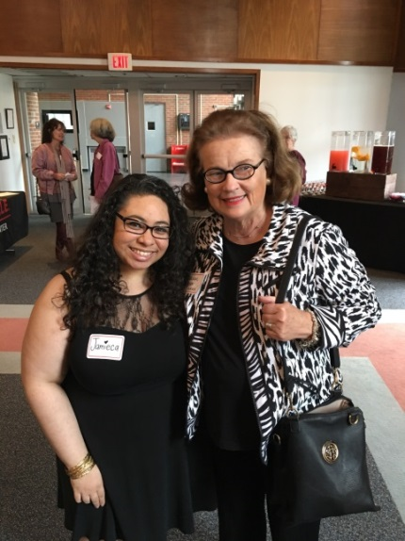
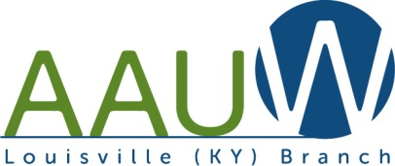
Louisville, KY Branch

“Notes from the President” – Susan Baker

Congratulations to the U of L Women's Center on their 25th Anniversary! Jamieca and Susan were among many prominent women at the celebration on March 21. AAUW, University branch and Louisville Branch, was recognized for our many contributions to the University of Louisville.

Board Members for the July 2017 to June 2018 Year

President Susan Baker
Communications Officer Jean Gordon
Finance Officer (treasurer) Ann Grubbs
Bylaws Charlaine Reynolds
Membership Director Faye Dykstra
Public Policy Director Teena Halbig
General Director Carolyn Diener
College University Partner Director Jameica Jones

Thank you to the members of the Leadership Team, who have agreed to continue their positions for one final year. Hope we’ll have members who are willing to become engaged and help lead our organization next year!

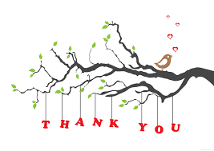
International Relations Programs
Rose Mary Toebbe has given us another year of fascinating, informative, and educational programs and is taking her well-deserved summer hiatus.
Programs will resume in October!!

Lunch Bunch

Get to know each other at lunch at different restaurants throughout the metro.
Usually meets on the 4th Friday of each month.

- Friday, June 30 at 12 noon (5th Friday) – Molly Malone Irish Pub
  - Corner of Shelbyville and Breckenridge Roads
  - RSVP with Ann Grubbs 502 - 409-6844 Annabellee35@aol.com

- Friday, July 28 at 12 noon - The Table
  - 1800 Portland Ave and 18th St
  - the unique restaurant in Portland where you pay what you are able to pay, there is no tipping, and the wait staff includes the owners mother and many working on community service requirements. Delicious soups, salads and sandwiches.
  - RSVP with Diane Snowa 502 - 254-7178 d.snowa@twc.com

- Friday, August 25 at 12 noon - Noosh Nosh (large diverse menu)
  - 4816 Brownsboro Center & I-264 (behind Anoosh Bistro)
  - RSVP with Ginny Copenhefer 502 - 893-5582 cope@win.net

- Friday, September 22 at 12 noon (to be determined)
  - RSVP with Evelyn Vance 502 - 245-0670 robertfvance@aol.com

- Friday, November 24 at 12 noon (to be determined)
  - RSVP with Jan Arnold 502 - 614-4216 janarnold59@yahoo.com

EDUCATIONAL PROGRAMS
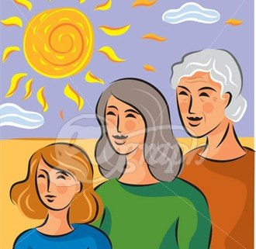
Join us this summer for more interesting programs and to meet
other members.

Thursday, July 13 – UNA-KY conference at St Paul’s Methodist Church -
- 7pm (information to follow)

Thursday, July 20 – 2nd annual summer luncheon at Faye Dykstra’s home
- Space Trek Camp fundraiser ; more details to be announced

EDUCATIONAL PROGRAMS (con’t)

Saturday, August 5, 10am: Indiana University SE Cultural Center - notable Indiana women and resources; tour of Claudia Crump’s Japanese gardens and home; Carpools to be arranged.
- lunch at Onion Asian Restaurant.
- RSVP with Carolyn Diener 502 - 893-8436 drtomdiener@msn.com

Saturday, August 26, morning – Suffrage Programs at Frazier History Museum
- collaboration of women’s groups (LWV, AAUW, etc)
- information to follow

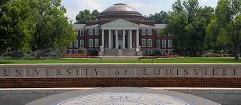

AAUW U of L Student Chapter Report - Jamieca Jones

Start Smart was facilitated by the awesome Charlaine Reynolds on April 13.

Our two executive members will be graduating this semester and the student AAUW group on the University of Louisville campus will focus on membership recruitment.

New Members
Welcome to our following new members. Please look for them at an event!!

Helene Trager-Kusman, M.Ed., an Academic and Career Advisor at Family Scholar House
502-438-8585 htkusman@familyscholarhouse.org.

She has a BS in Early Childhood Ed from Univ. of Maryland College Park, and a MS in Education from Walden Univ.

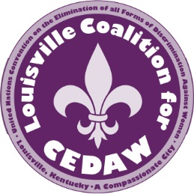
CEDAW (Convention to Eliminate Discrimination Against Women)
The Louisville Coalition for CEDAW (LCC) is an organization whose mission is to connect with leaders and community members in the metro area, through outreach and development of grass roots coalitions and broad strategic alliances, to support gender equity through education, advocacy, and action.

- Join us for coalition meetings at the Bon Air Library 2816 Del Rio Place each month on the second Tuesday from 6:30 to 8pm
- Contact Jean Gordon for further information 502 – 618-2174 gordon.jean@twc.com

7 members attended CSW: Commission on The Status of Women at the United Nations Headquarters in New York in March 2017. The priority theme was: Women’s economic empowerment in the changing world of work. Those who attended reported on the amazing feeling of empowerment when so many women united in ending discrimination, worked together.

Teena Halbig President UNA-KY - continues to lead her organization to bring awareness, education, and an end to Human Trafficking in our state, in support of the CEDAW principles.

Family Scholar House (FSH)

Remember: The Family Scholar House is a local non-profit organization that our branch actively sponsors. Donations of money, products, and time are always welcome. To learn more, visit their website at www.FamilyScholarHouse.org or call 502.584.8090

Special Interest Groups
Anyone is welcome to join one of the Special Interest Groups, by contacting the name below:

- Literature Group – a book club which meets monthly on Monday mornings
  - Evelyn Vance: 502-245-0670 Email: robertvance@aol.com

- Supper Club – group that eats out last Saturday of each month
  - Ceelie Chilko (H) 896-8132 (C) 502-544-6039 Email: chilkoj@bellsouth.net

- Dining Out - 2nd Saturday of each month at various restaurants in the Louisville area
  - Pam Steffen: 502 - 459-4934 Email: steffenpam@gmail.com

It has been a busy year with many more activities and programs coming. Get involved!! Bring friends!! Help support the AAUW mission to empower women.

Check out our website: http://louisville-ky.aauw.net/ and our Facebook page.

If you have anything you’d like to contribute for future newsletters, please contact:

Jean Gordon Communications Director
gordon.jean@twc.com 502-618-2174

