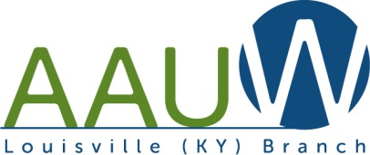
American Association of University Women (AAUW)
Louisville, KY Branch

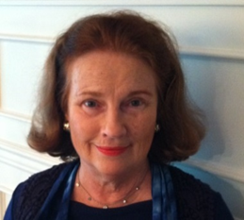
“Notes from the President” – Susan Baker

Our Board met in January and plans are underway for 2018, our one hundredth year!
On Jan 22 Carolyn Diener, Teena Halbig, Emily Boone and I attended the Metro Louisville Women's Political Caucus Summit to follow up on proposals put forward at Women's Equality Day. We are moving forward. Two of our branch members, Teena Halbig and Jamieca Jones will be attending the Council on the Status of Women at the United Nations in March. Board member and our CEDAW liaison Jean Gordon is inviting our branch to hear a presentation by Marta Miranda at the next CEDAW meeting February 13 at the Bon Air Public Library. Member Diane Snowa is offering our membership two opportunities to learn about women of the Three Abrahamic Faiths on Feb 5 and Feb 12. All of this is in addition to our regular interest group meetings.
Please mark your calendars for our next general meeting on March 10 at the University Club 11:00-1:00. AAUW Louisville Branch Past, Present and Future. You will hear a little about our past, a lot about what we are doing on the U of L campus, and where we are headed. If you are still invested in empowering women and girls please attend and bring a friend.

History Project - work continues on the expanded directory and history. Our publisher is Noble Pub. The date for the 100th Birthday is Friday Sept 14 at the University Club 5:00 pm - 7:30 pm.
There will be a cocktail buffet, guest speaker and birthday cake and champagne. More details to come.
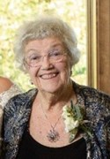
On January 27 AAUW Louisville lost a champion. Janice Richmond, a Life member, exemplified the AAUW woman. Her leadership in our Book Group opened our horizons. Her leadership in Gourmet treated our members to incomparable meals. She and her husband traveled the world and brought their experiences back to us in many captivating programs over the years. Her career as a woman of faith and an advocate for girls and women was an inspiration to all of us. A Celebration of her remarkable life will be Saturday February 3 at Highlands Funeral Home.
Onward!
Susan Henson Baker

International Relations Programs
Rose Mary Toebbe invites you to attend these interesting & informative monthly programs.

February 5: “ORIGINS OF LOUISVILLE ORIGINALS” Speaker, Steve Wiser. Hear origins of such companies as Pappa Johns, Louisville Slugger, Humana, KFC, and Pappy Van Winkle's Bourbon, the most expensive in the world. Steve, an architect, has written articles for THE COURIER-JOURNAL, been on TV, and is one of our most interesting speakers.

March 5: “MYSTERIOUS DEATH OF MERRIWEATHER LEWIS” Speaker, Jim Holmberg
After hearing Jim debate if it was murder or suicide, you can decide for yourself. Jim is Curator of Special Collections at the Filson Historical Society.

April 4: “DARK HIGHWAYS – LOVE, MURDER, AND REVENGE” Speaker & Author, Ann Dangelo. tells a fascinating true story of a well-liked, beautiful widow who was murdered by a powerful politician – the Lt. Governor of Kentucky. This story of two murders in 1936 received national attention.

May 2: “SUSTAINABLE AGRICULTURE” Speaker, Leah Bayens. Leah is the young Director of the Wendell Berry Farming Foundation Center which partners with a Kentucky college in studying agriculture and farming. Wendell Berry's daughter is the founder of this organization. Wendell is the adviser, active board member, and a well known Kentucky writer and poet.

When: 1st Wednesday of each month
Place: Treyton Oak Towers – Coffee 10:30am – Program 11:00 am
Lunch: To reserve call Lawrence Toebbe 459-6119 by noon Monday
Cost: Lunch is $12.00 and is optional.

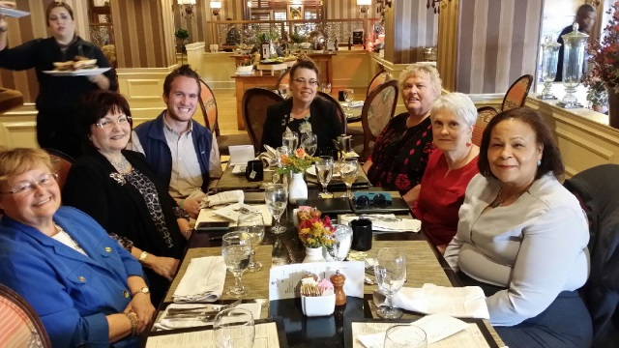
Congressional In-District Meeting: AAUW Focus on Equal Pay by Teena Halbig

As AAUW Louisville Branch and AAUW KY Policy Chair, Teena Halbig took the latest AAUW national information on pay equity to an October, 2017 meeting with Andrew Condia, the field representative for Senator Mitch McConnell.

Mr. Condia was delighted that the pay information was distilled to show each Congressional District and the corresponding percentage women received. Interestingly, while the national average is 80 cents to a man's $1.00, in District 3 of Congressman John Yarmuth, women's pay was nearly 87 cents!

Overall pay figures for the Commonwealth of Kentucky were shocking! Men $46,000 and women $36,000 = $10,000.00 less for a woman per YEAR. Equal pay remains an extremely important economic issue for women - and affects retirement benefits, as well as quality of life for families and children.
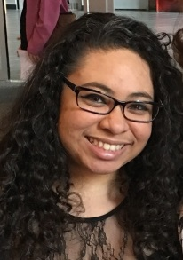
AAUW U of L Student Chapter Report - Jamieca Jones

A new Executive Board has been elected and we're excited to see their leadership grow individually and as an organization. They will be working on recruiting more members.

AAUW at UofL created a Tampon Task Force in 2016. Through its advocacy, the University will be supplying 26 personal hygiene product dispensers on the 3 campuses - which will be free for students; the Women’s Center is distributing stocked baskets to buildings without dispensers and donations are sought to keep them stocked. Educational programs and information will be offered on campus. Our local chapter is also a proud sponsor!

March: Women in Space program for Women's History Month. A speaker from NASA is in the planning stage and the event will be hosted by the Women's Center, Women & Gender Studies Department, UofL's Planetarium, and UofL's Society of Women in Physics and Astronomy.

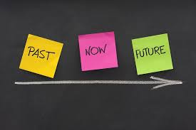
April: Equal Pay Day Bake Sale and Start Smart Program.

General Members Meeting

AAUW Louisville Past, Present, and Future

- Saturday, March 10: 11:30am to 1pm
- University Club on U of L campus
- Lunch is $25
- RSVP: Susan Baker (502) 974-4866 nonnymomm@aol.com

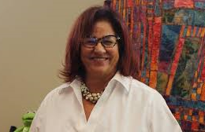
Educational Programs

Louisville Coalition for CEDAW
(Convention to Eliminate Discrimination Against Women)

Tuesday, February 13 6pm to 7:30pm
Bon Air Public Library 2816 Del Rio Place

Join us as Marta Miranda-Straub will walk us through the fundamental, crucial aspects of implementing CEDAW in Louisville: feminism, intersectionality, and advocacy for survivors of gender based violence from a human rights perspective.

Council on the Status of Women Report by Teena Halbig and Jamieca Jones
- Wednesday, April 25 11am
- Salad Lunch at Carolyn Diener’s house
- RSVP with Carolyn Diener 502 - 893-8436 smittycsd33@gmail.com
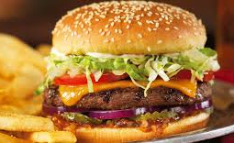
Lunch Bunch

Get to know each other at lunch –
usually meets monthly on the 4th Friday

- Friday, February 23 at 12 noon Gander: An American Grill 111 S English Station Rd in Landis Lakes Towne Center, corner of Shelbyville and South English Station Road 40245
  - RSVP with Faye Dykstra 502- 245-8172 or hairpuller@bellsouth.net

- Friday, March 23 at 12 noon Sword and Scone Tea Parlor & Boutique 1915 Blankenbaker Pkwy 40299 (between Commonwealth and Plantside Drives)
  - RSVP with Teena Halbig (502) 267-6883 teenahal@aol.com

- Friday, April 27 at 12 noon Uptown Cafe 1624 Bardstown Rd, 40205
  - RSVP with Susan Baker (502) 974-4866 nonnymomm@aol.com

New Members
Welcome to our following new members. Please look for them at an event!!

Amber Arnold - a Career Coach & Employer Liaison at IU Southeast, has recently returned from Portland, Oregon where she was involved in PDX Women in Tech, Techtown Diversity, and other local initiatives. Her MA in Psychology is from the The Chicago School of Professional Psychology.
Joyce Anderson – has been a long time member of AAUW and has recently returned from Hot Springs Arkansas. Her career centered on healthcare administration, she is a fiber artist and loves sharing discussions about books

Check out our website: http://louisville-ky.aauw.net/ for upcoming events; list of Study Groups with contact information; International Relations Programs; and AAUW links and updates. Thanks to Faye Dykstra and Cena Hoffman, Webmaster.
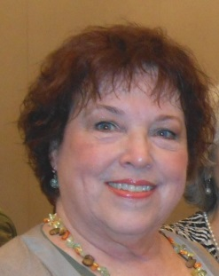

If you have anything you’d like to contribute for future newsletters, please contact: Jean Gordon Communications Director
gordon.jean@twc.com 502-618-2174

