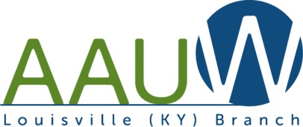
American Association of University Women (AAUW)
Louisville, KY Branch

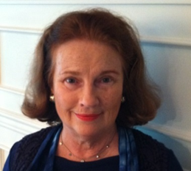
“Notes from the President” – Susan Baker
In public life these days some may be stepping down, but from my vantage point, many are stepping up. Teena Halbig is taking the advocacy part of our mission to a new level. The Ban Salary History Ordinance is moving forward. Kathy Matheny and friends have started a new Book Group. Teena and Jameica Jones were at the United Nations for the Council on the Status of Women. Many of you have given generously to our memorial fund enabling our Branch to help with a NCCWSL scholarship. I had the privilege of representing Louisville at the State Convention in Owensboro where I had a productive meeting with Dr Julia Brown, president of AAUW Trustees. And speaking of stepping up, Rebecca Stutsman will soon assume presidency of the Louisville Branch. Congratulations, Rebecca!

Our 100th Birthday Celebration is set for September 14 5:00-7:00 pm at the University Club on the U of L campus. Suzanne Gould, AAUW Historian will be coming in from Washington to help us celebrate. Work continues on the History Project, with an expanded directory and history. Our publisher is Noble Pub.

But we are not just looking back. The Branch continues to advance efforts for pay equity and to support our UL Branch while collaborating with other groups and our national organization on projects empowering girls and women. One project we are learning more about is local; it is Louisville Girls Leadership and it is worthy of our support!

This year is your time to step up. Girls and women in our community, and beyond need to be supported and empowered now, as much as one hundred years ago. The Branch needs your support. For us to continue to move forward please renew your membership and consider bringing a friend into AAUW. Please contact lapsed members and encourage them to support our Branch with membership and/or contributions.

One project for the future worthy of AAUW support is portraying women and their accomplishments in public statues and portraits. Today the only statue of a woman in Louisville is Colonel Castleman's horse, a filly. If you would like to celebrate this Mother's Day in a unique way travel to Lexington's Wellington Women's Garden on May 13 for the unveiling of Katsina, a representation of the feminine spirit. More statues are coming. Let's make an effort to bring more of the women of our community into public view! There are plenty of opportunities!

Onward,
Susan

AAUW Louisville Branch Officers for 2018-2019

President – Rebecca Stutsman
Treasurer – Ann Grubbs
Public Policy – Teena Halbig
Communications – Jean Gordon and Joyce Anderson
Membership – Susan Baker and Faye Dykstra
U of L Liason – Jamieca Jones
Members at Large – Carolyn Diener and Charlaine Reynolds

AAUW Louisville Membership Dues

Our fiscal year is June 31, 2018 until July 1, 2019, and dues are payable by the end of June.
Dues are still $72.00 for regular members of the branch; $17 for student members; and $25 for Life members. Honorary Life members are free.

Make your check to AAUW and mail to: Ann Grubbs 5113 Rock Water Drive, Louisville, KY 40241
502-409-6844 Annabellee35@aol.com

AAUW Louisville Philanthropic Fund

At our last Board Meeting we decided unanimously to establish a designated Philanthropic Fund for our Branch to educate and empower girls and women locally. This fund includes donations made to honor members and memorials.

- Contributions are made out to AAUW Louisville and sent to Ann Grubbs.

Some examples of our recent philanthropy are scholarships to SpaceTrek, National Conference for College Women Student Leaders, support to participants of many conferences such as the Commission on the Status of Women, and support for conferences which support our mission such as Women’s Equality Day, UNA and CEDAW.

If you have any questions please contact any board member.

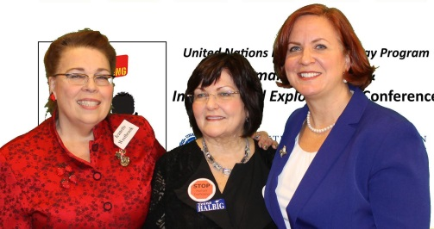
Jeanette Westbrook, Tina Halbig, Jeanne Smoot

Commission on the Status of Women

Congratulations to Teena Halbig, who was selected as the national delegate to CSW62 at the UN by UNA-USA, to present “Human Trafficking & CEDAW: Meeting Challenges & Utilizing Opportunities”. She moderated and convened a panel composed of Dr. Lisa Baldez from Dartmouth College; Jeanette Westbrook, MSSW, UNA-USA KY; Karolina Lukasiewicz, Post doctoral NYU. Around 200 worldwide attendees listened attentively for 90 minutes and most wore their new “STOP Human Trafficking Pins”. The audience was informed that for about a decade, UNA-USA KY and UNA-USA Louisville Chapter had been working on Human Trafficking. Article 6 of the Convention on the Elimination of all forms of Discrimination Against Women (CEDAW) states “take all appropriate measures, including legislation, to suppress all forms of trafficking in women and exploitation of prostitution of women.”

As Public Policy Chair for AAUW Louisville Branch and Kentucky, Teena’s trip to NYC was co-sponsored by AAUW Louisville. Teena described her work with AAUW national office Public Policy Manager Kate Nielson to have a proposed ordinance for Louisville Metro for Banning Salary History. NOTE: This will be heard and voted on by Louisville Metro Council Members on May 10 at 6pm in Metro Chambers.

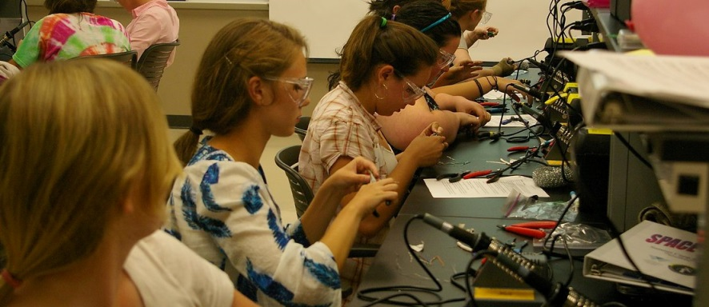
Space Trek Camp 2018

Space Trek will be held for the 7th year at Morehead State University July 6 – 13, 2018. This program gives young high school women an introduction to space science engineering and the opportunity to launch their own space bot. 12 to 27 students have attended each of the past years.

About 33% of the students entering the space science program, a 4-year undergraduate program at Morehead State, are women.

Support is received from the Ashland Area Branch, the Kentucky Division of AAUW, and the AAUW Louisville Mary Morrison Scholarship (which contributes $250 annually).

AAUW members are invited to attend the graduation on Sat. 7/14 at 10am. A light lunch follows this event. Donations are welcome in support of this program.

Contact Faye Dykstra 502-718-6710 hairpuller@bellsouth.net
AAUW U of L Student Chapter Report - Jamieca Jones
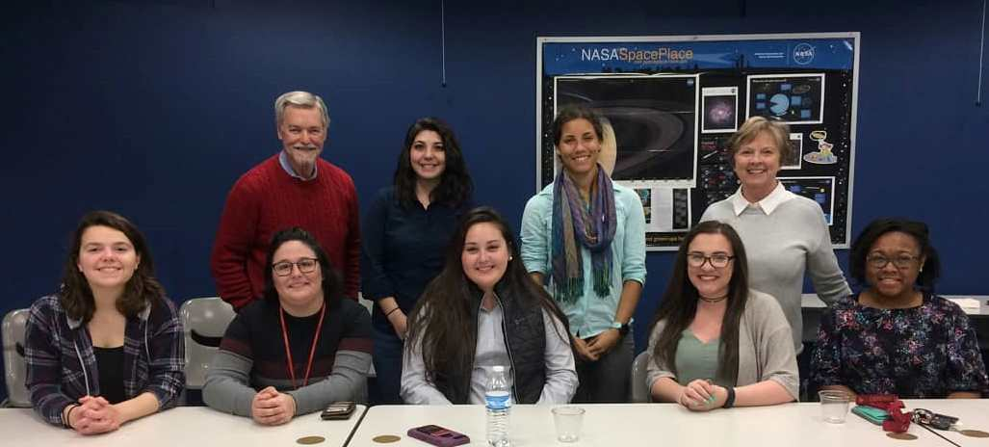
- Women in Space event was a success with 225 in attendance for the 3 days. Our students had the opportunity to meet with our Women in Space Keynote Sophia Mitchell, NASA Aerospace Engineer!

- Olivia Grace King, an AAUW UL officer, will be attending the National Conference for College Women Student Leaders (NCCWSL) in Washington DC and has been awarded a $300 scholarship from the Jan Richardson Memorial Fund, AAUW Louisville

- Start Smart- Due to a sudden increase in the program fee, from $300 to $750, the students won't be hosting the workshop this semester, but hope to raise funds for next year

- Working on recruitment and programs for the fall.

International Relations Programs

There is one final program coming up before the summer break. Rose Mary Toebbe hopes that you enjoyed the program selection and will continue to attend.

June 6, 2018: “TALES OF THE TRAILS” Speaker, Jeanne James. Jeanne walked the Road of Pilgrims in northern Spain, a road that pilgrims from all over Europe travel along the way of St. James. The “shell” symbolizes the foot path along the road. Jeanne will tell us of her adventures walking 500 miles in northern Spain.
Treyton Oak Towers – Coffee 10:30am – Program 11:00 am. Join us for lunch at $10. RSVP with
Lawrence Toebbe 459-6119 by noon Monday

Friday, August 24: Membership Meet & Greet
- Wine and Cheese with Leslie Nichols, artist in residence at Western Kentucky University
- 5pm to 7pm University Club

Come and join us and bring anyone you know!!!!

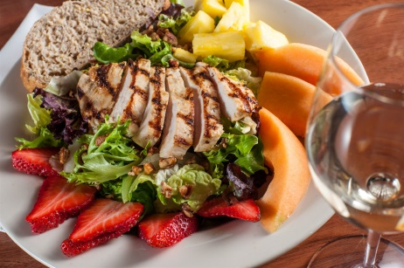
Lunch Bunch

Get to know each other at lunch –
usually meets monthly on the 4th Friday at noon

Friday, May 25 at 12 noon PF Changs
- 9120 Shelbyville Rd Hurstbourne
  - RSVP with Jean Gordon 502-618-2174 gordon.jean@twc.com

Friday, June 22 at 12 noon Clover Lane
- 211 Clover Lane at the Colony Center, St. Matthews (near intersection of Westport and Shelbyville Rds
  - RSVP with Pam Steffen 502-459-4934 steffenpam@gmail.com

Friday, July 27 at 12 noon MojitoTapas
- 2231 Holiday Manor Center on Brownsboro Road
  - RSVP with Carolyn Diener 502 - 893-8436 smittycsd33@gmail.com

Friday, August 31 (5th Friday) at 12 noon Sisters Tea Parlor & Boutique
- 4765 Fox Run Rd, Buckner, KY 40010 (off of Hwy 146; Exit 17 on I 71)
- RSVP with Ann Grubbs 502-409-6844 Annabellee35@aol.com

After Hours Book Club
Do you crave intellectual stimulation and discussion? Do you enjoy good conversation with interesting women? So do we!

Visit or join the After Hours Book Club. We meet on the second Monday of each month at 6:30, with a half hour for snacks and socializing, and book discussion starting at 7:00.

The books we have selected have a common theme of women who have overcome limitations imposed upon them due to their gender.

Date: May 14
Book: Bad Girls of the Bible: And What We Can Learn From Them
Author: Liz Curtis-Higgs
Moderator: Lynne Wood
Venue: 1740 Sulgrave Road 40205

Date: June 11
Book: The Road of Lost Innocence: The True Story of a
Cambodian Heroine
Author: Somaly Mam
Moderator: Chelsea Norman
Venue TBD

Date July 9
Book Whiskey Women: The Untold Story of How Women
Saved Bourbon, Scotch, and Irish Whiskey
Author: Fred Minnick
Moderator: Kathy Matheny
Venue: Taste Fine Wines and Bourbon Store 634 E. Market 40202
Bourbon tasting ! to go with our book

Future meetings will be announced. Please come join us !
Kathy Matheny 502-419-4648 krmatheny78@gmail.com

Other books that have been picked but not assigned a month or moderator:
Wild: From Lost to Found on the Pacific Crest Trail, by Cheryl Strayed
The Glass Castle: A Memoir, by Jeanette Walls
Irena’s Children: The Extraordinary Story of the Woman Who Saved 2500 Children from the Warsaw Ghetto, by Tilar J. Mazzeo
Marie Antoinette: The Journey, by Antonia Fraser
December Meeting: Pick a new theme and list of books for 2019

Check out our website: http://louisville-ky.aauw.net/ for upcoming events; list of Study Groups with contact information; International Relations Programs; and AAUW links and updates.
- Thanks to Faye Dykstra and Cena Hoffman, Webmaster.

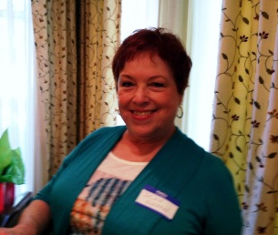
If you have anything you’d like to contribute for future newsletters, please contact:
Jean Gordon Communications Director 502-618-2174 gordon.jean@twc.com

